**Case Study- Peer Code Review (PCR)**

**Aim:**

***To create an application for performing the following tasks.***

a. Read the contents of one of the files (that you would like) into an ArrayList.

b. The user should be able to enter a boy/girl’s name as input

c. The application will display messages indicating whether the name was among the most popular.

d. It also displays if the name is contained in (substring) any of the most popular names.

**Code:**

**//Importing the required libraries**

import java.io.BufferedReader;

import java.io.FileReader;

import java.io.IOException;

import java.nio.charset.StandardCharsets;

import java.nio.file.Files;

import java.nio.file.Paths;

import java.util.ArrayList;

import java.util.Collections;

import java.util.List;

import java.util.*;

import java.io.File;

import java.util.Arrays;

import java.util.Optional;

public class ReadFileIntoArrayList {

public static void main(String[] args) throws Exception {

**// Reading the input file “BoyNames.txt”**

Scanner s=new Scanner(new File("BoyNames.txt"));

**//Converting the Text file to the Array list**

ArrayList<String> listS=new ArrayList<String>();

ArrayList<Integer> listI=new ArrayList<Integer>();

while(s.hasNextLine())

listS.add(s.nextLine());

System.out.println(listS);

**//Coverting the Arraylist to Array**

String array[] = new String[listS.size()];

for(int j =0;j<listS.size();j++){

array[j] = listS.get(j);

}

**//Getting input from the user**

Scanner sc= new Scanner(System.in);

System.out.print("Enter a string: ");

String input= sc.nextLine();

boolean stringExists = substringExistsInArray(input, array);

System.out.println(stringExists);

System.out.println(getFirstMatchingSubstring(input, array));

**//Checking whether the substring of the input exits in array**

if(stringExists==false){

String b=input.substring(0,3);

for(int i=0;i<=array.length-1;i++){

if((array[i].substring(0,3))==b){

if(stringExists==false){

System.out.println("The substring of the input is contained in the array");

}

}

}

}

**//If the input not exits in array**

else if(stringExists==false){

System.out.println("The input "+ input +" is not contained in the array");

}

**//If input is existed in the array**

else{

System.out.println("The input "+ input +" is contained in the array");

}

}

public static boolean substringExistsInArray(String inputStr, String[] items) {

return Arrays.stream(items).parallel().anyMatch(inputStr::contains);

}

public static Optional getFirstMatchingSubstring(String inputStr, String[] items) {

return Arrays.stream(items).parallel().filter(inputStr::contains).findAny();

}

}

**Result:**

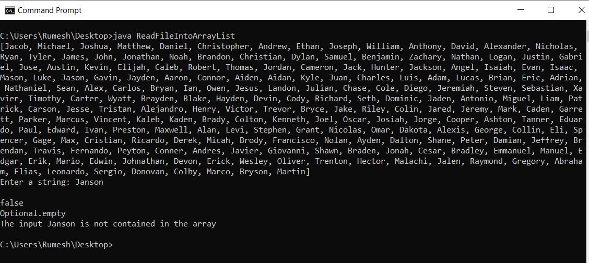

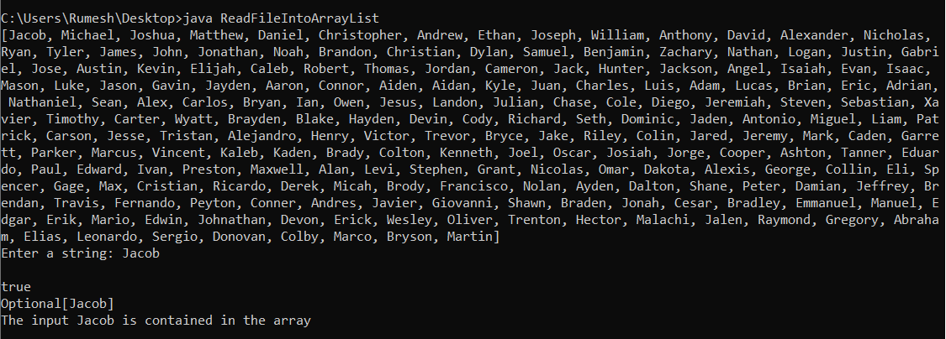

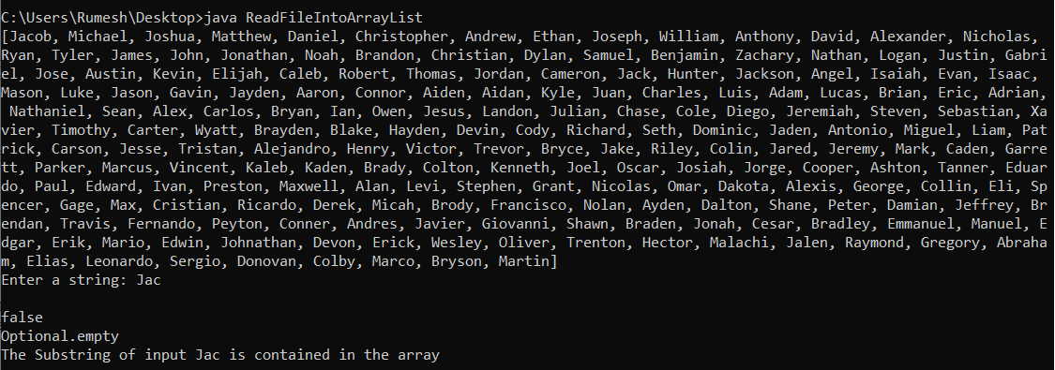

**Result:**

Thus, the code with above condition is implemented.